**WEEK 10:**

**Assignment 2 Integrating static analysis tools into the development lifecycle-Defender for DevOps**

C:\Users\BETTY\AppData\Local\Temp\ksohtml13752\wps1.png

Report by: Vallary Akinyi Ogolla **CS-CNS06-24142**.

C:\Users\BETTY\AppData\Local\Temp\ksohtml13752\wps2.png

**Introduction**

In this lab, I explored the integration of static analysis tools into the development lifecycle using Microsoft Defender for DevOps. This exercise involved configuring Microsoft Security DevOps, a command-line application that automates the installation, configuration, and execution of various static analysis tools to enhance security and compliance in software development. Through hands-on experience with tools like Bandit, ESLint, Credscan, and more, I gained practical insights into how these tools can be integrated within Azure DevOps and GitHub Actions to identify and address potential security vulnerabilities early in the development process.

**Objectives**

By the end of this lab, I aimed to achieve the following objectives:

* Conduct a Static Application Security Testing (SAST) scan locally using Bandit.
* Configure the Microsoft Security DevOps extension within Azure DevOps.
* Set up and configure Microsoft Security DevOps GitHub Actions for automated security scanning.
* Utilize the DevOps Security Workbook to gain insights into security metrics and findings**.**

**Lab Environment**

• Azure DevOps

• GitHub Actions

**Methodology**

Exercise 1: Import the vulnerable code

1. On GitHub, fork the vulnerable code from S2FrdQ/VulnDjango (github.com)

2. On Azure DevOps, create a new Private project and name it VulnDjango. Navigate to Repos,

and import the vulnerable code from <https://github.com/S2FrdQ/VulnDjango.git>

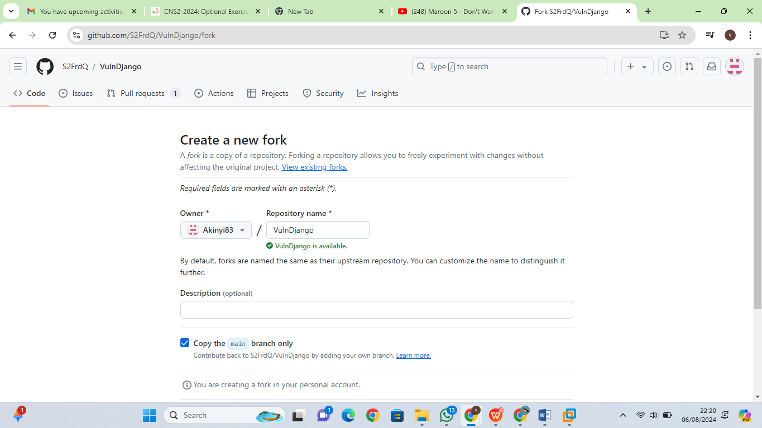

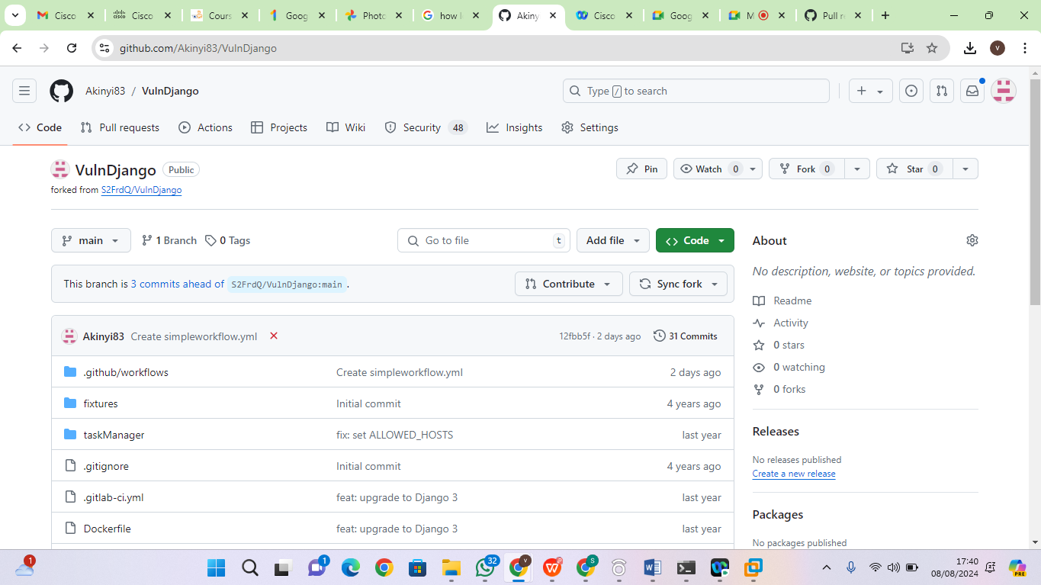

**Exercise 2:** SAST scan using Bandit locally.

**Bandit -** The Bandit is a tool designed to find common security issues in Python code. To do this Bandit, processes each file, builds an AST, and runs appropriate plugins against the AST nodes. Once Bandit has finished scanning all the files it generates a report. Bandit was originally developed within the penStack Security Project and later rehomed to PyCQA.

i.Download the source code locally – **git clone https://github.com/S2FrdQ/VulnDjango webappdjango** then **cd webappdjango**

ii.Install Bandit **pip3 install bandit**

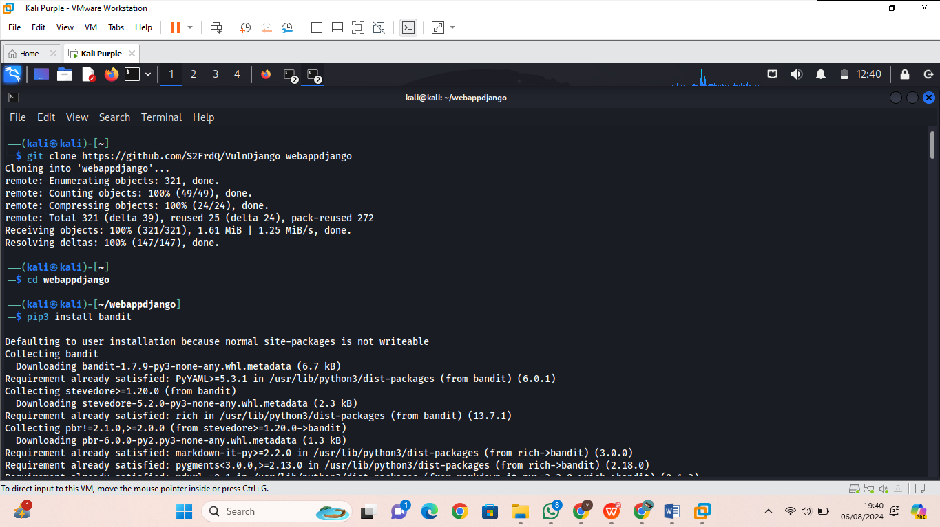

iii.If a warning is issued to add Directory to path, add using the below command.

**export PATH="/home/kali/.local/bin:$PATH"** To explore bandit --help

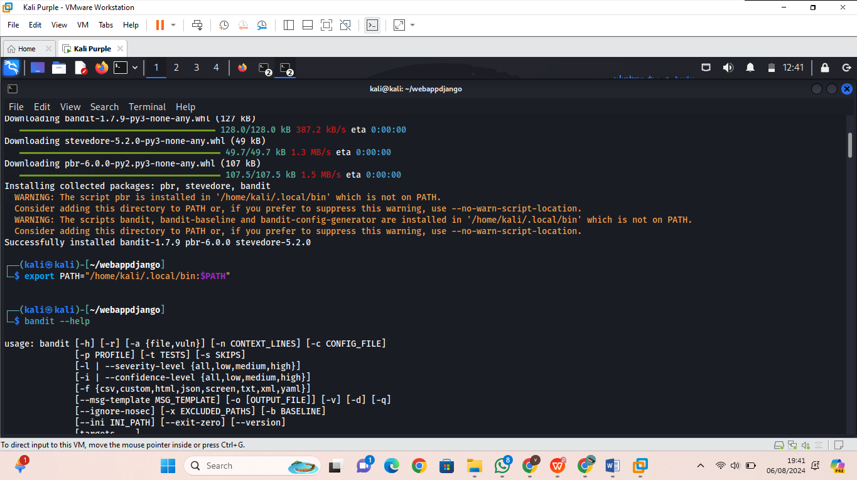

iv.Run the scanner - We are using the **tee** command here to show the output and store it in a file simultaneously. **bandit -r .** Basic scan

**bandit -r . -f json | tee bandit-output.json**

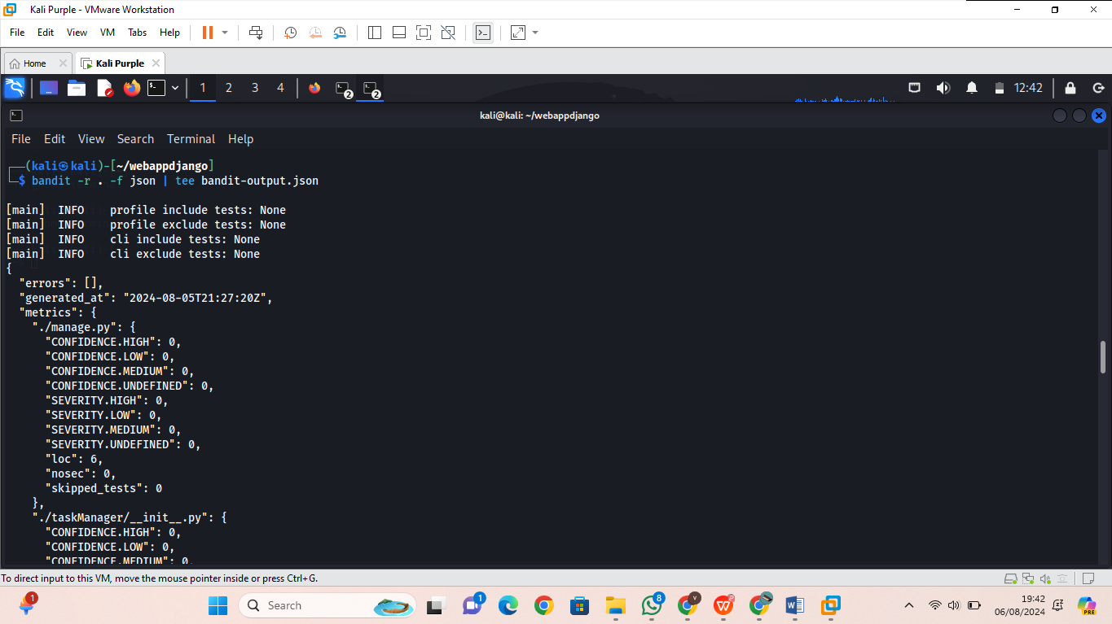

**Exercise 3:** Configure the Microsoft Security DevOps Azure DevOps extension.

**Note:** Admin privileges to the Azure DevOps organization are required to install the extension.

1. Activate Microsoft Security DevOps extension – on your Azure DevOps portal with the **VulnDjango** project open, click on the marketplace icon > **Browse Marketplace**.

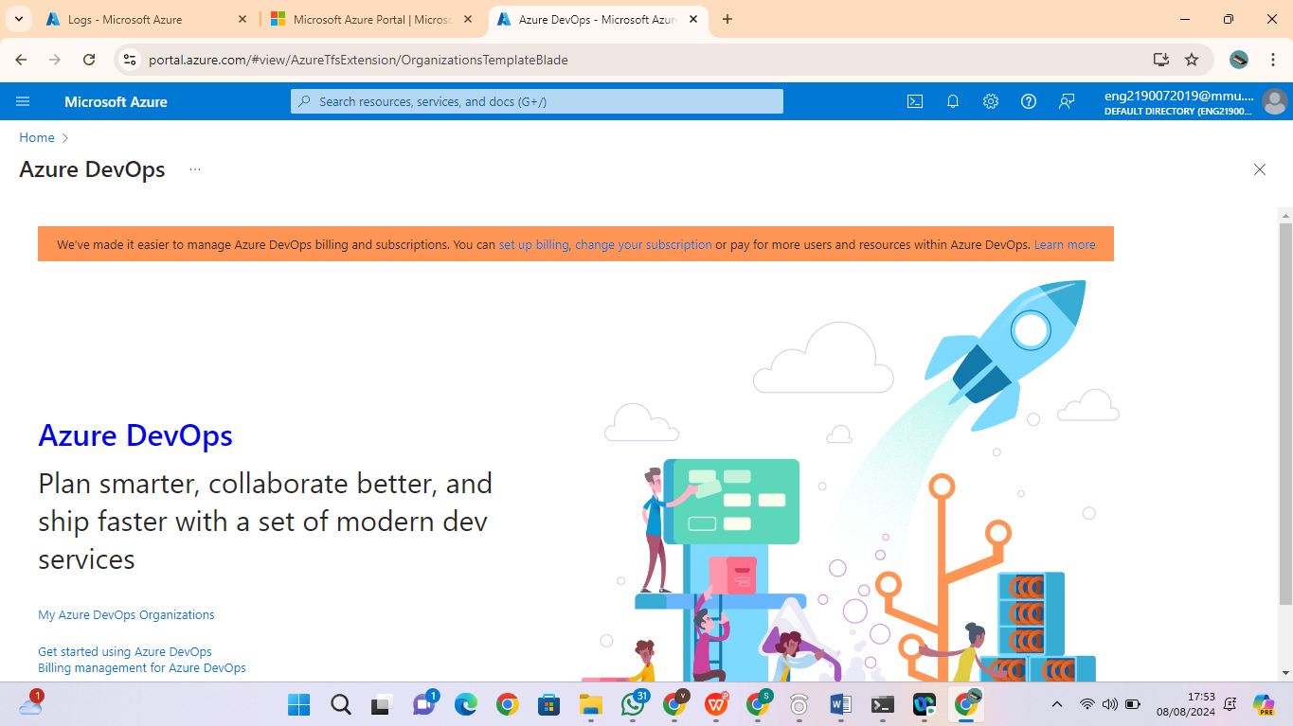

2. On the Marketplace, search for **Microsoft Security DevOps** and open it.

3. On the **Microsoft Security DevOps** page, click on **Get it for free**.

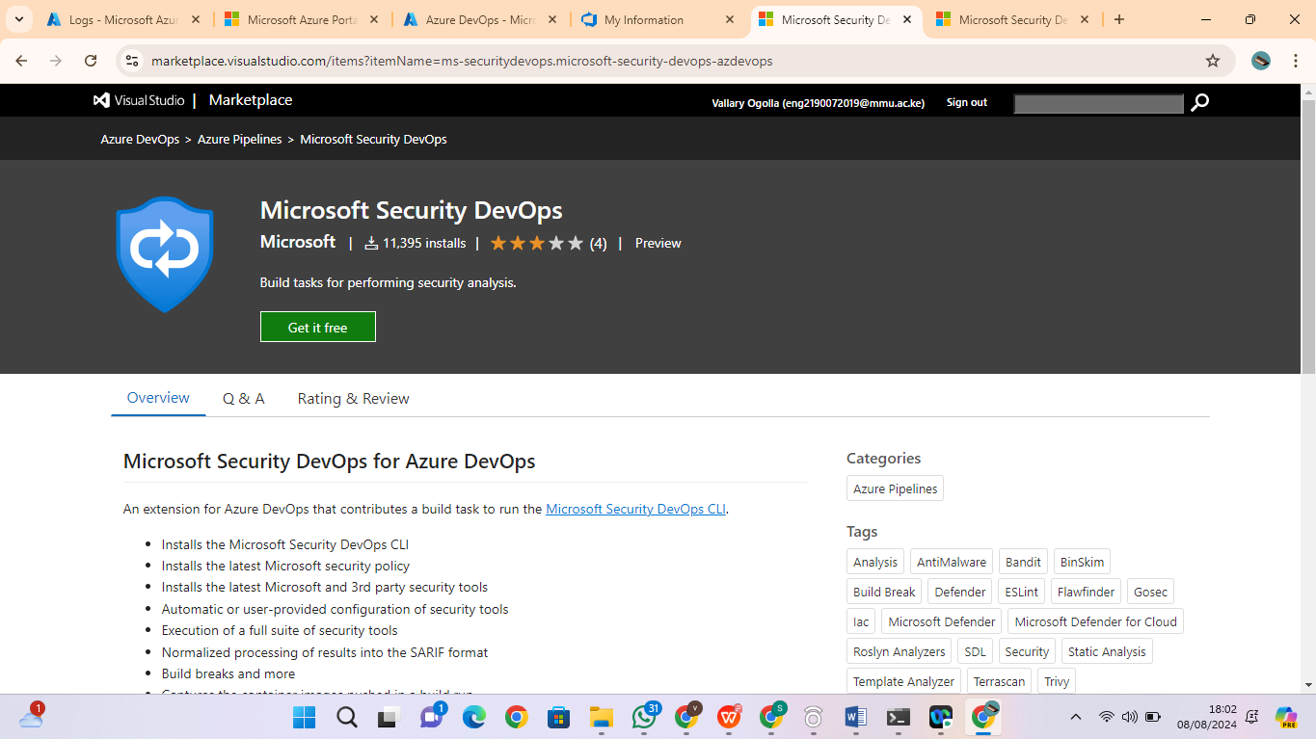

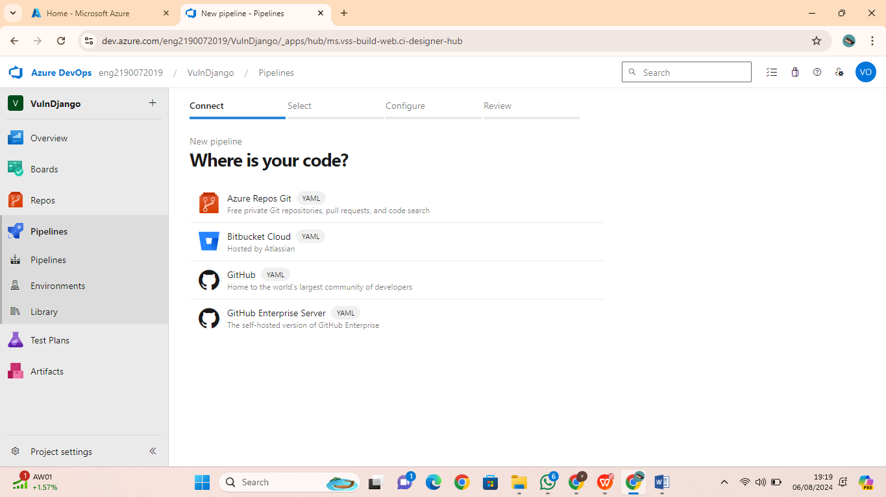

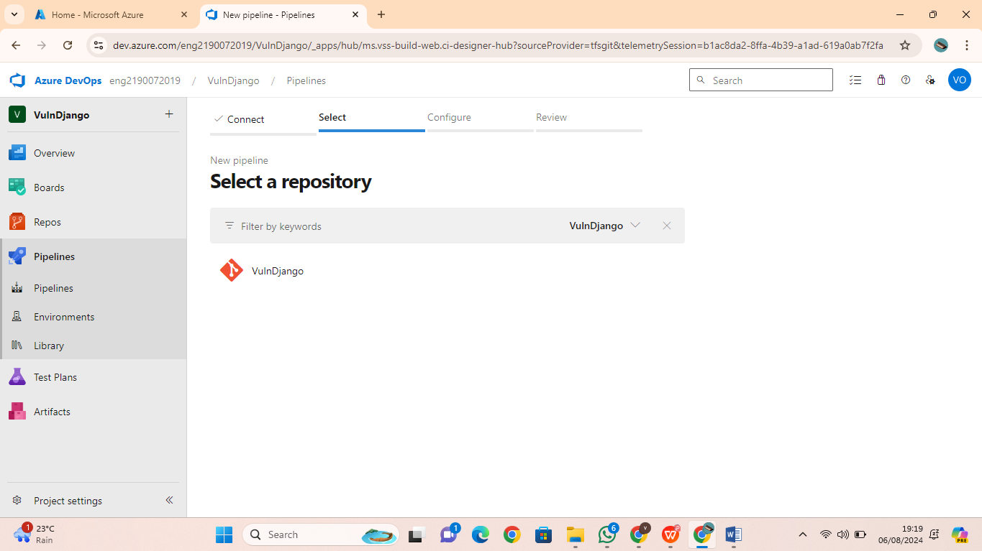

4. On the next page, select the desired Azure DevOps organization and Install. Proceed to

organization once installed.

5. Navigate to your VulnDjango project, then Pipelines and Click New pipeline.

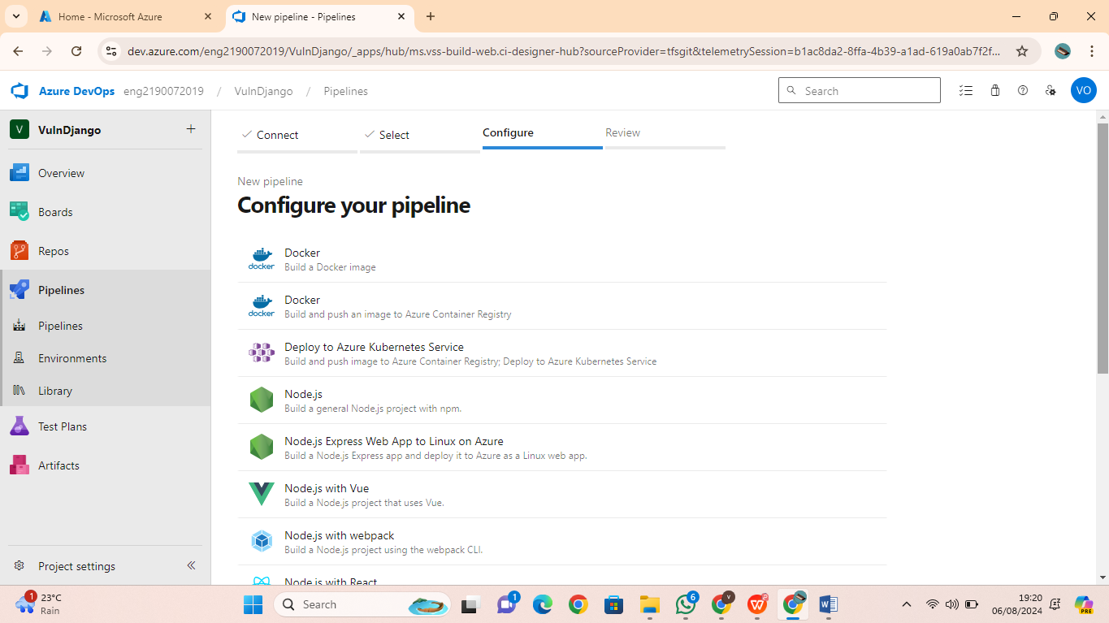

6. On the Where is your code? window, select Azure Repos Git (YAML) and select

the VulnDjango repository.

7. On Add the following scripts as in into the yaml file

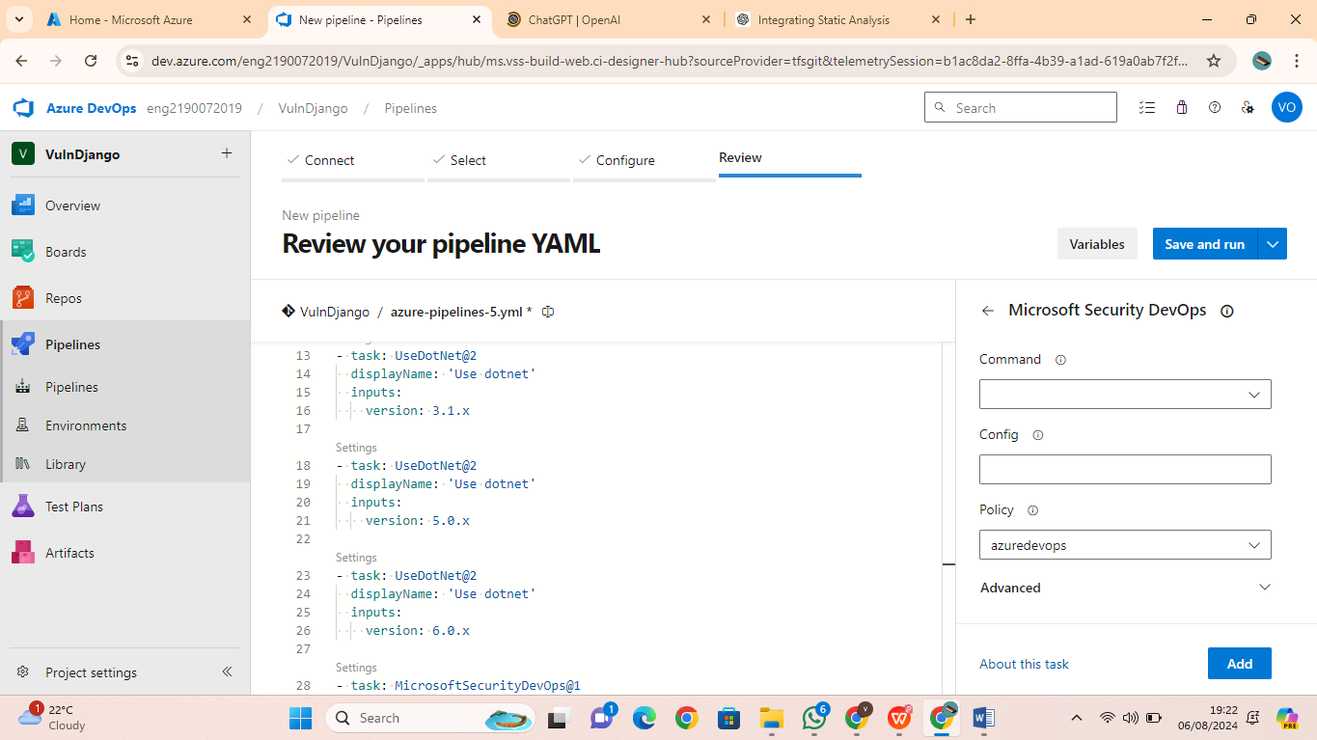

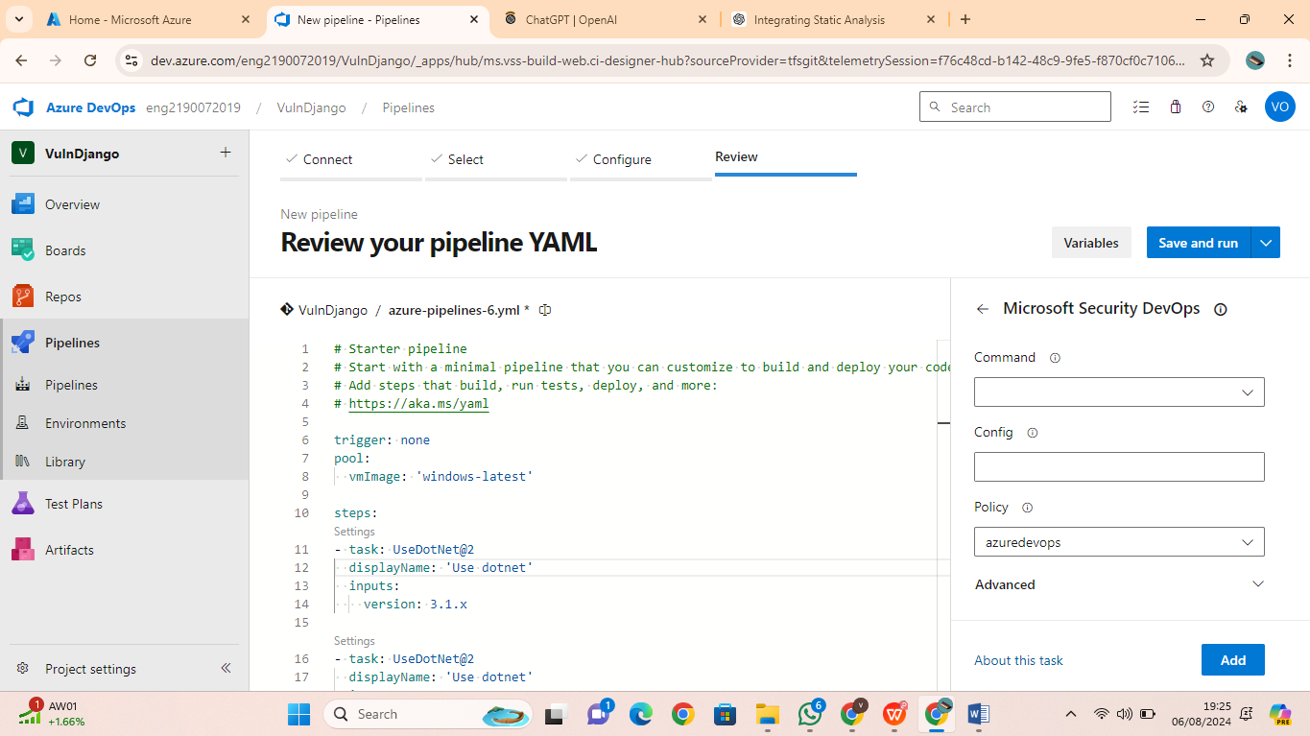

8. Click Save and run and let the pipeline run. You can check progress by going to Pipeline-Pipelines and select the running pipeline.

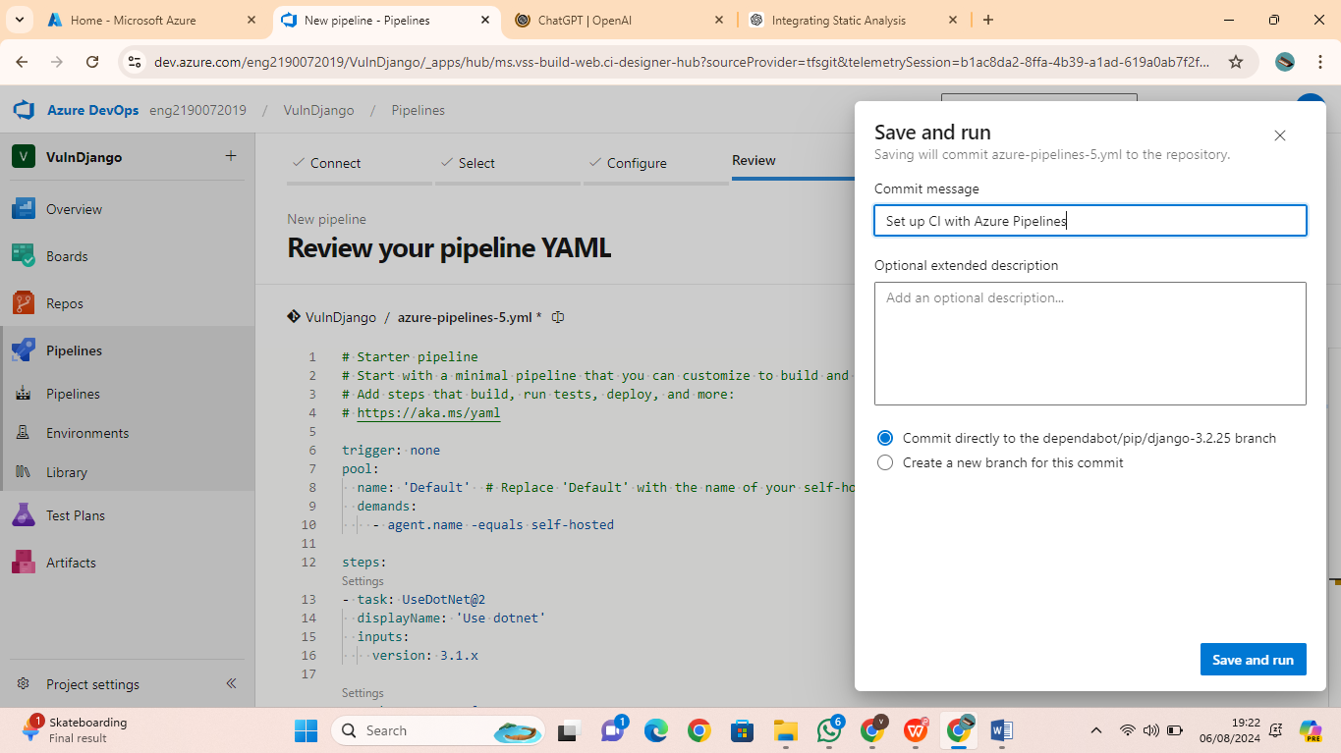

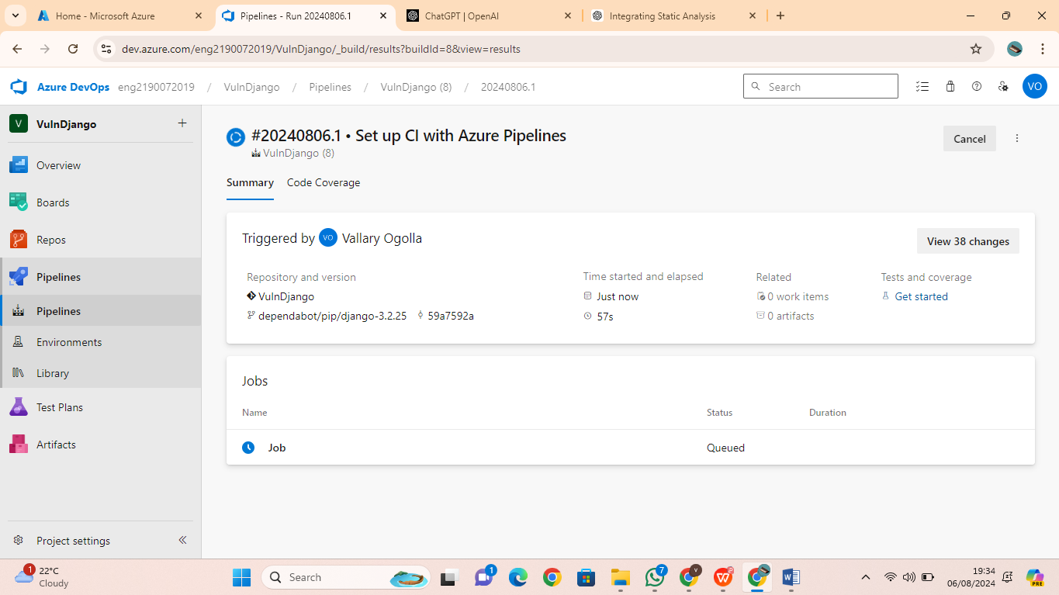

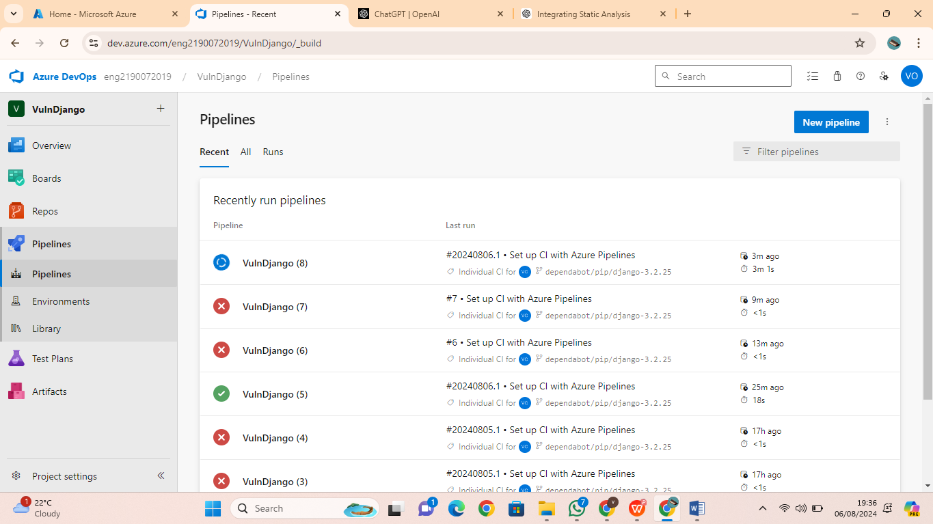

9. When done, you can view security vulnerabilities found by **Microsoft Security DevOps** , by clicking Scans

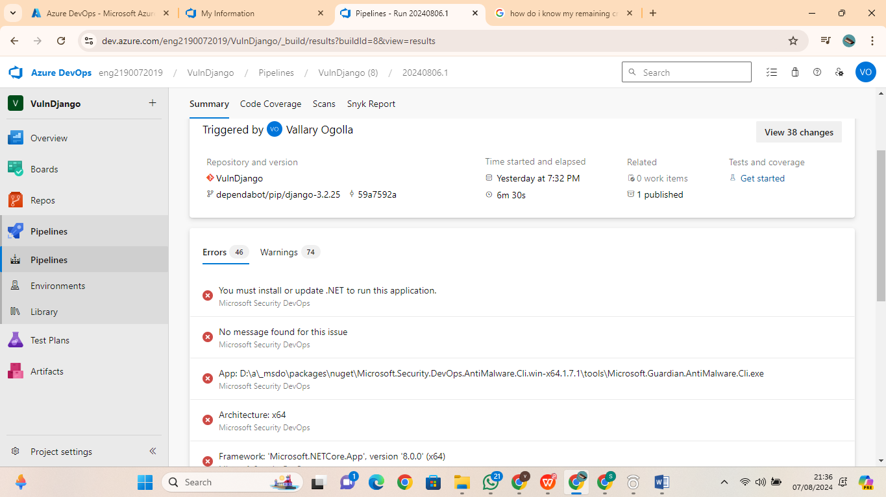

**Note**: Install the SARIF SAST Scans Tab extension on the Azure DevOps organization in order to ensure that the generated analysis results will be displayed automatically under

the Scans tab**.**

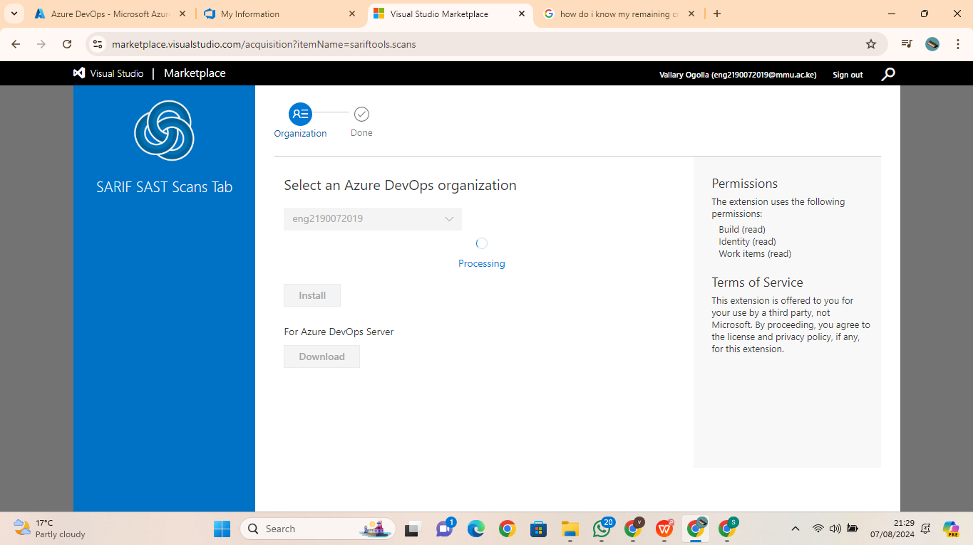

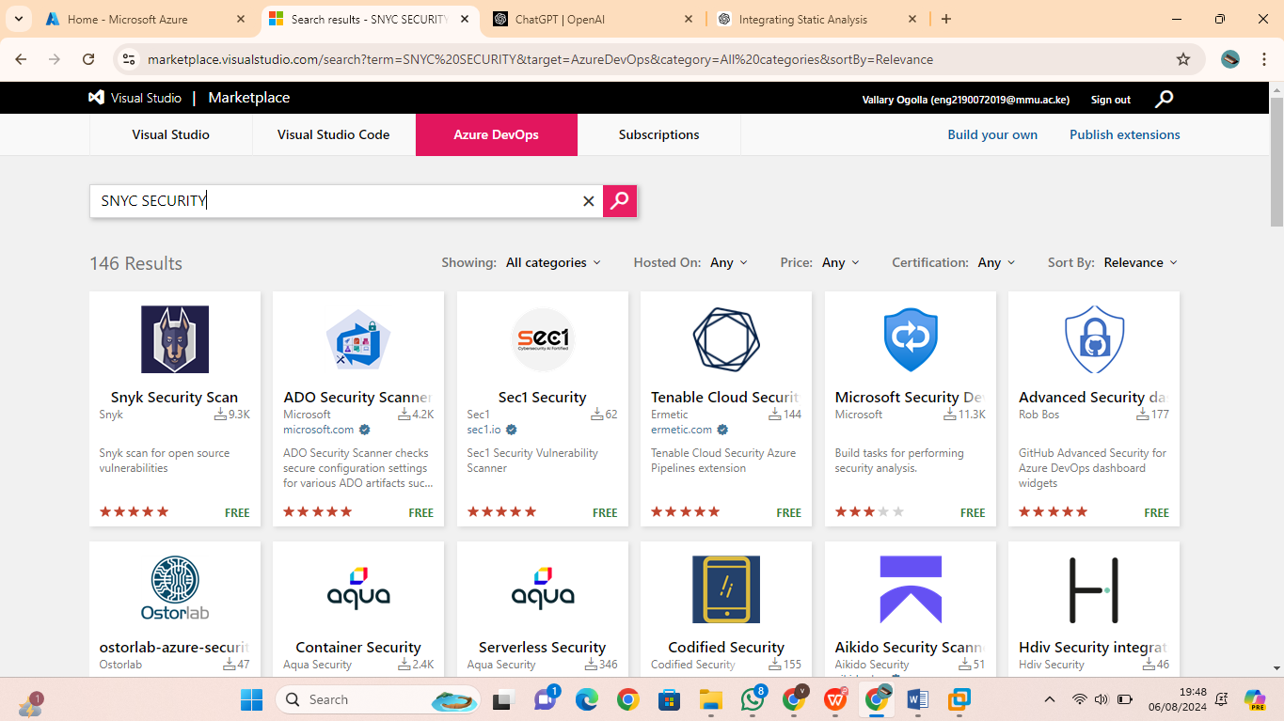

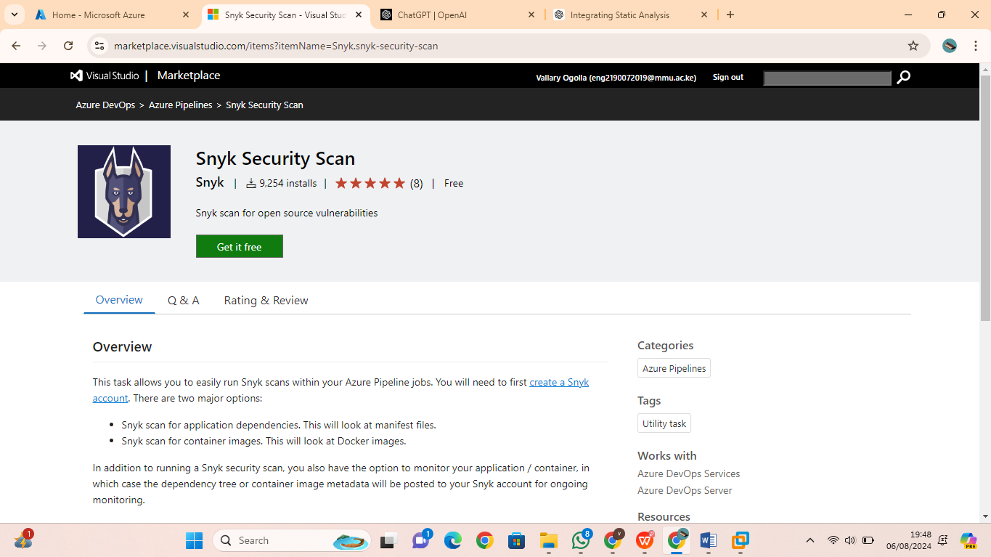

**Exercise 4: Configure the Microsoft Security DevOps GitHub actions**

1. Navigate to your VulnDjango GitHub repo.

2. Select Actions

3. Select **New workflow**.

4. On the Get started with GitHub Actions page, select **set up a workflow yourself**

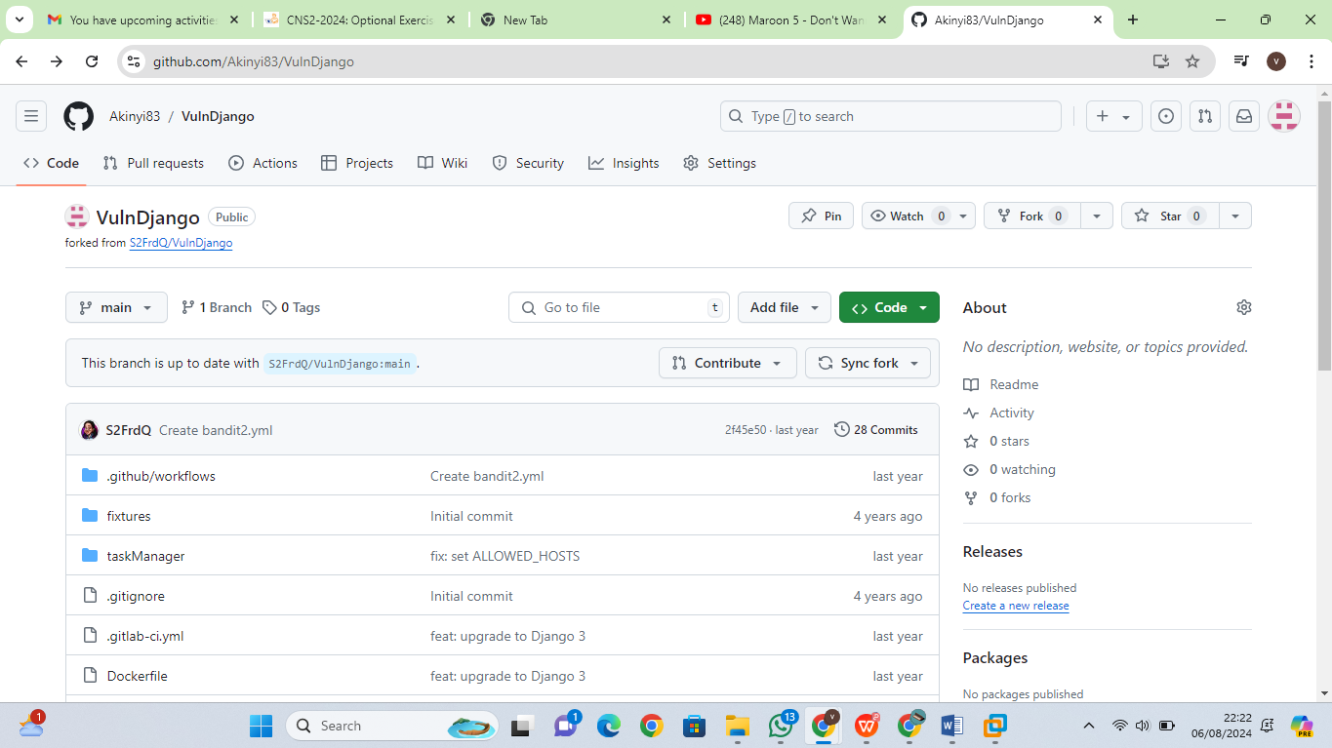

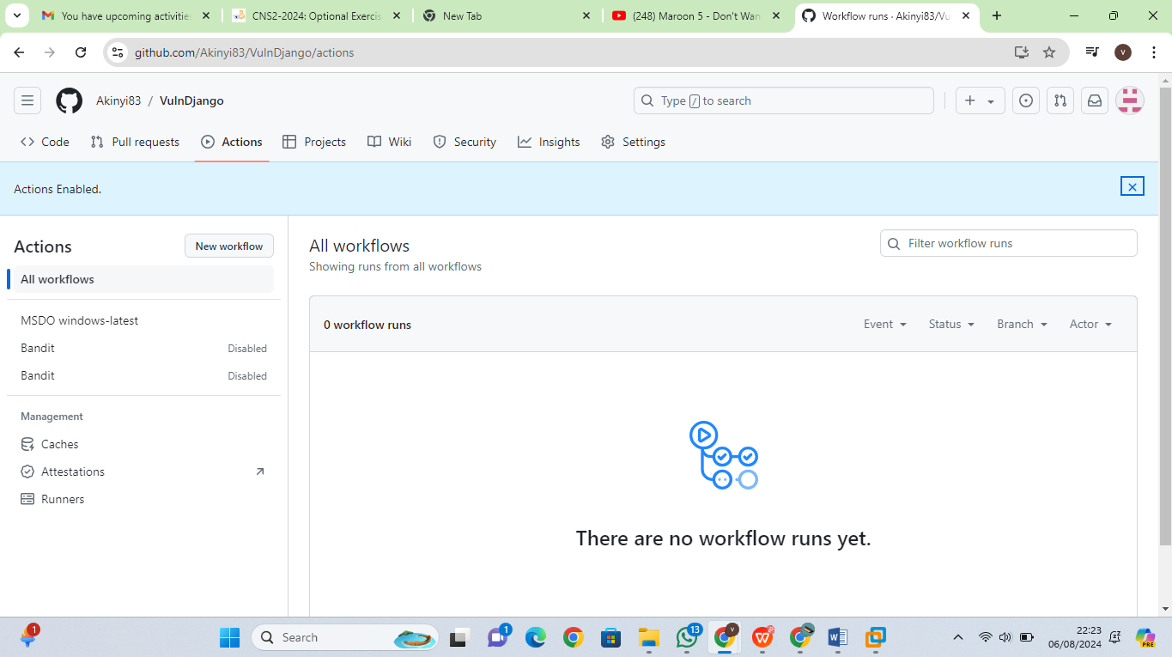

5. In the text box, enter a name for your workflow file. For example, msdevopssec.ym. I named it **Simple workflow**

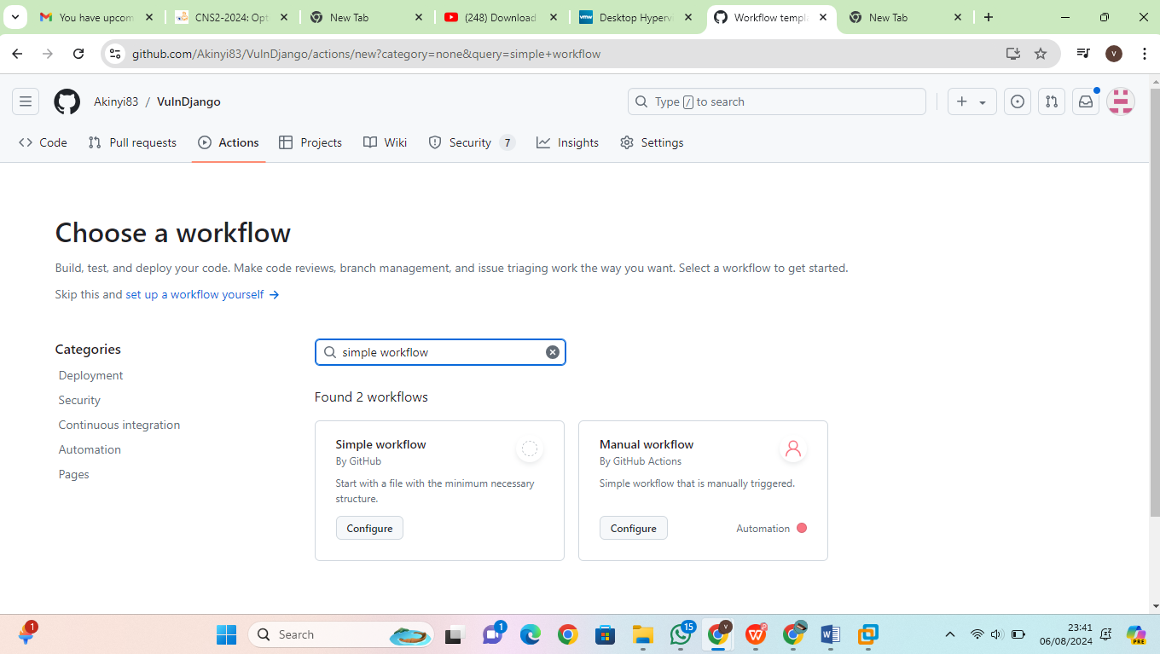

6. Copy and paste the following sample action workflow into the Edit new file tab.

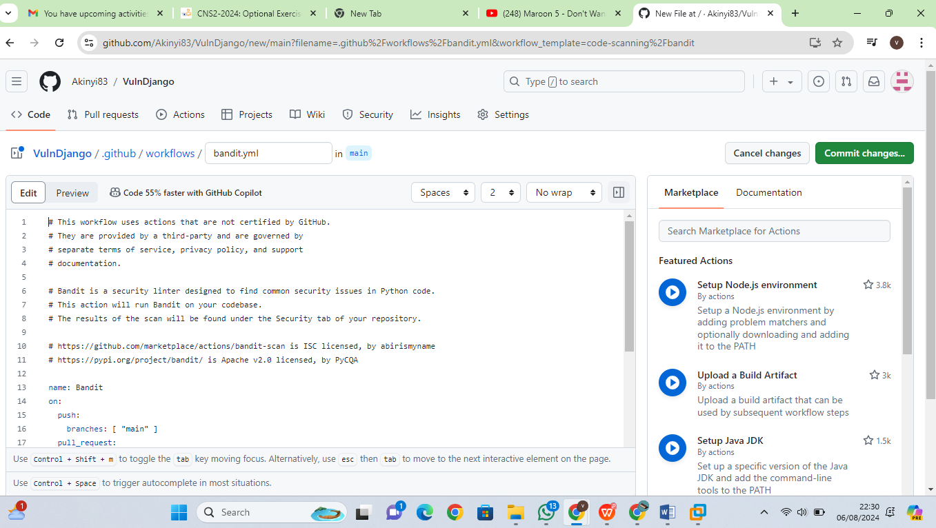

10. Select **Actions** and verify the new action is running.

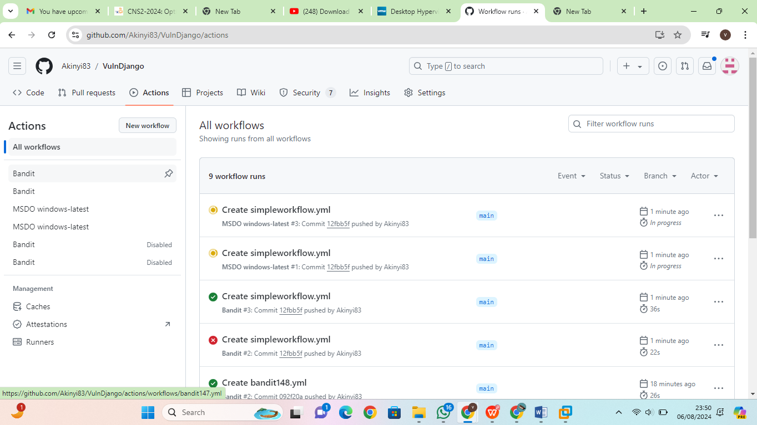

View Scan Results: Navigate to **Security** > **Code scanning alerts** > **Tool**. From the dropdown menu, select **Filter by tool**. Code scanning findings will be filtered by specific MSDO tools in GitHub. These code scanning results are also pulled into Defender for Cloud recommendation

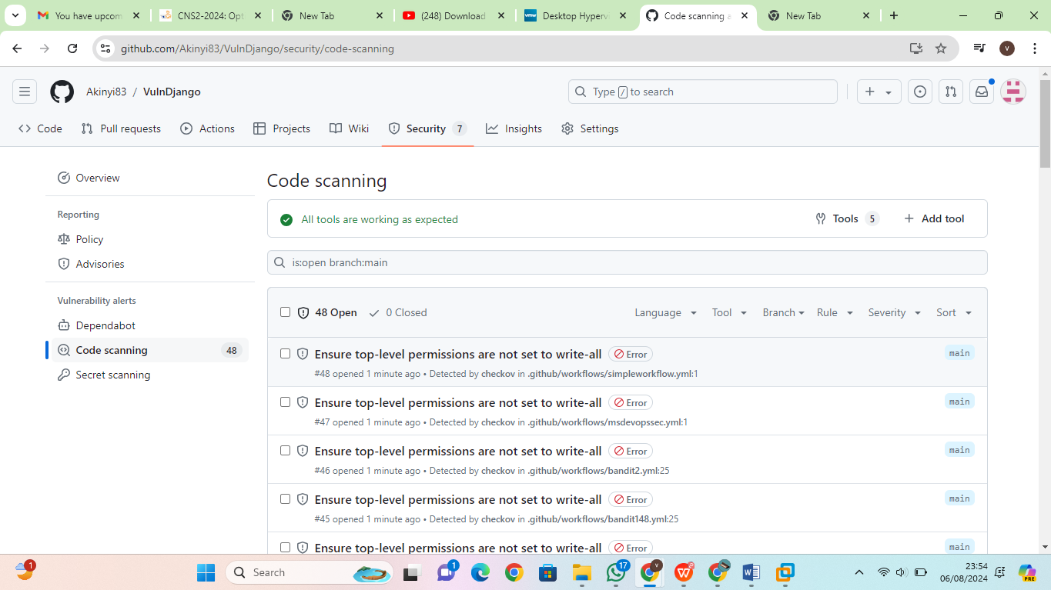

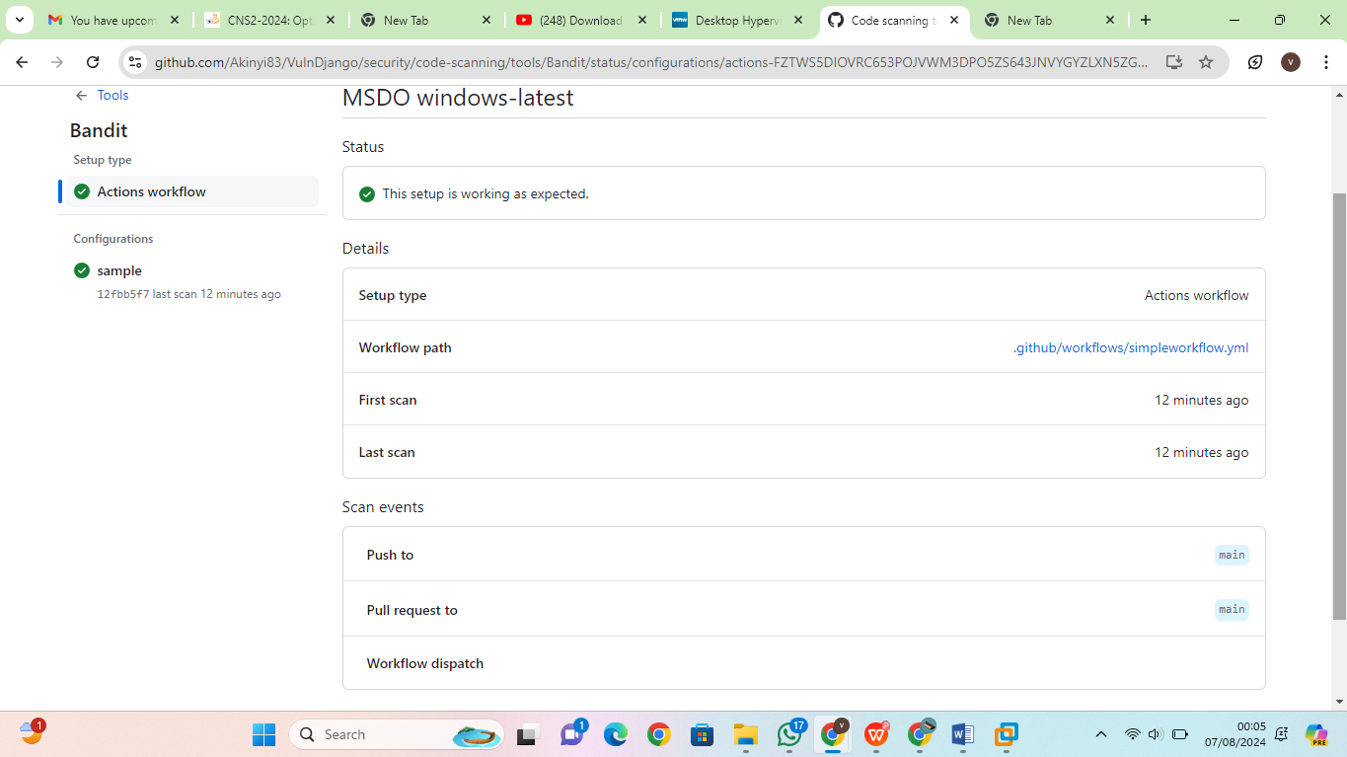

I also created a Bandit.yml file to also deploy scans using bandit

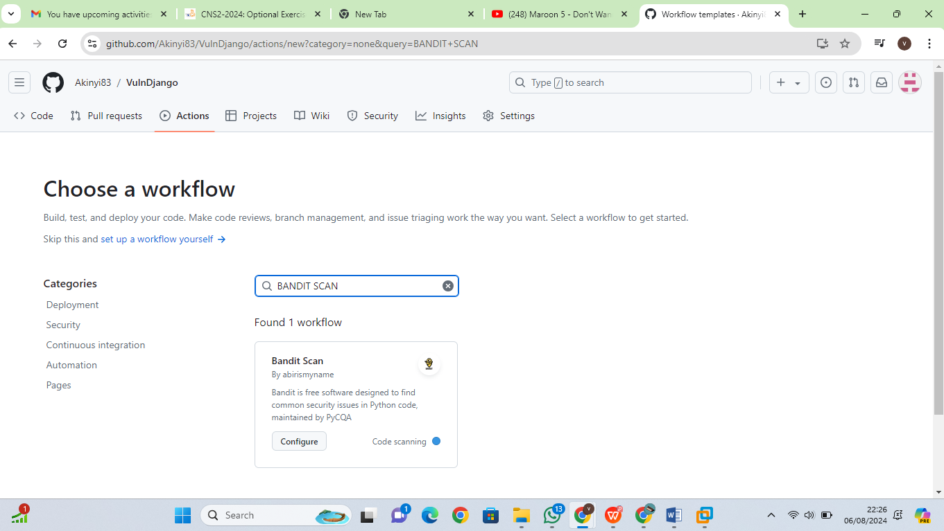

Once Bandit Scan is configured it adds a YAML file into my workflow then I proceed to commit it. Then it will go in and start the pipeline.



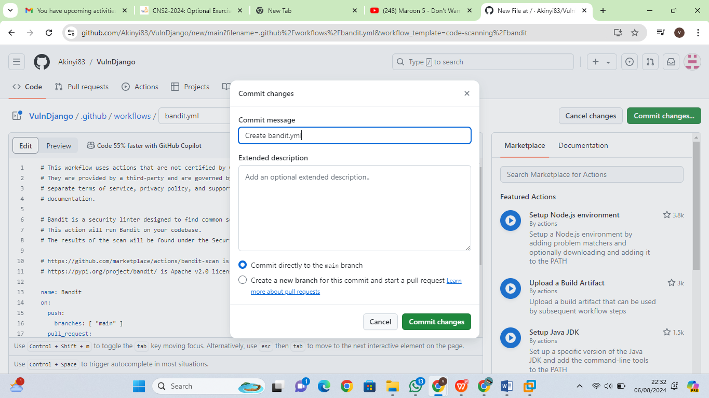

I changed the file name of bandit file and committed the changes

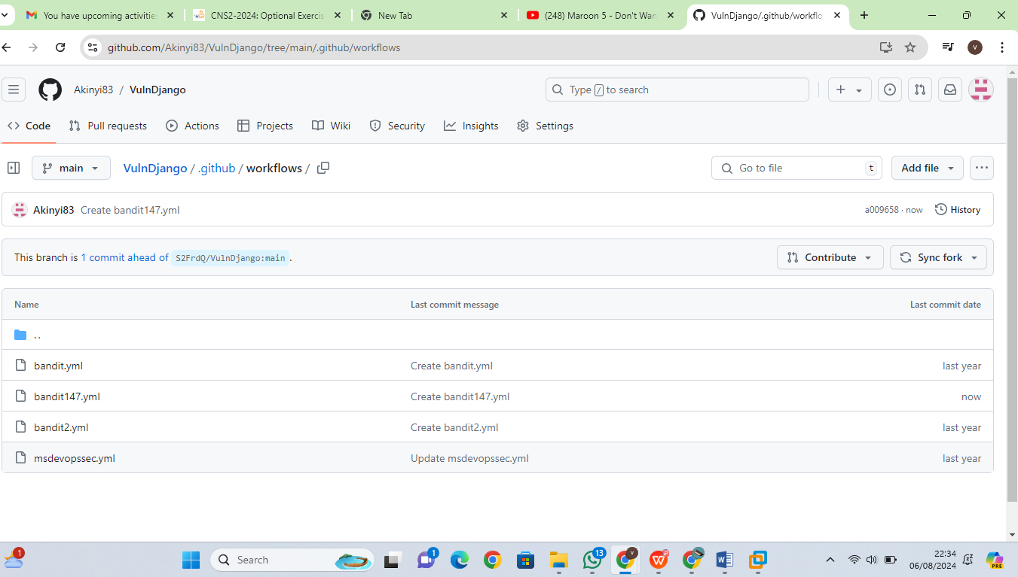

View Scan Results : Navigate to **Security** > **Code scanning alerts** > **Tool**. From the dropdown menu, elect **Filter by tool**. Code scanning findings will be filtered by specific MSDO tools in GitHub. These code scanning results are also pulled into Defender for Cloud recommendations

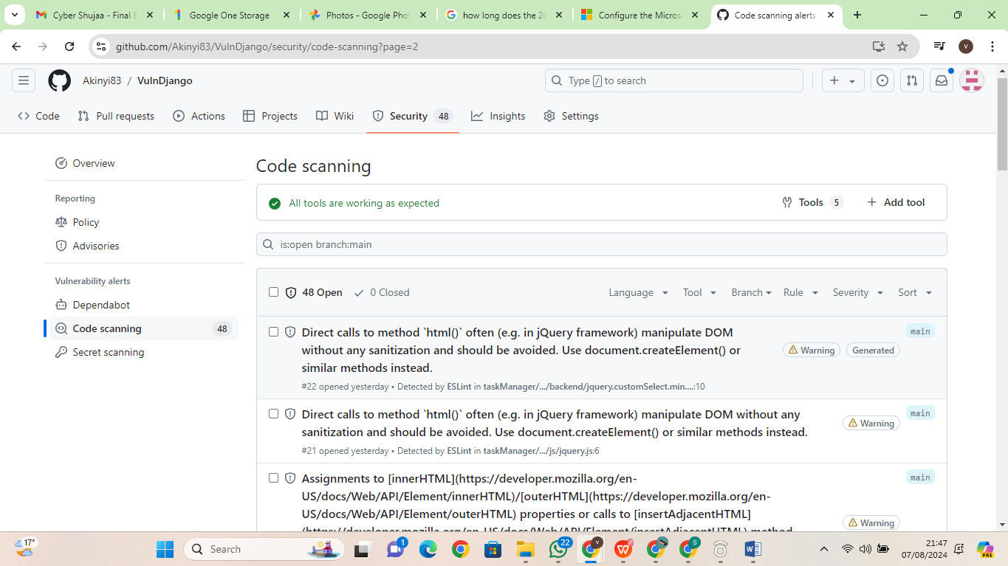

**Exercise 5: DevOps Security Workbook**

Navigate to Defender for Cloud, click on Workbooks, then click on **DevOps Security (Preview)** to launch the Workbook.

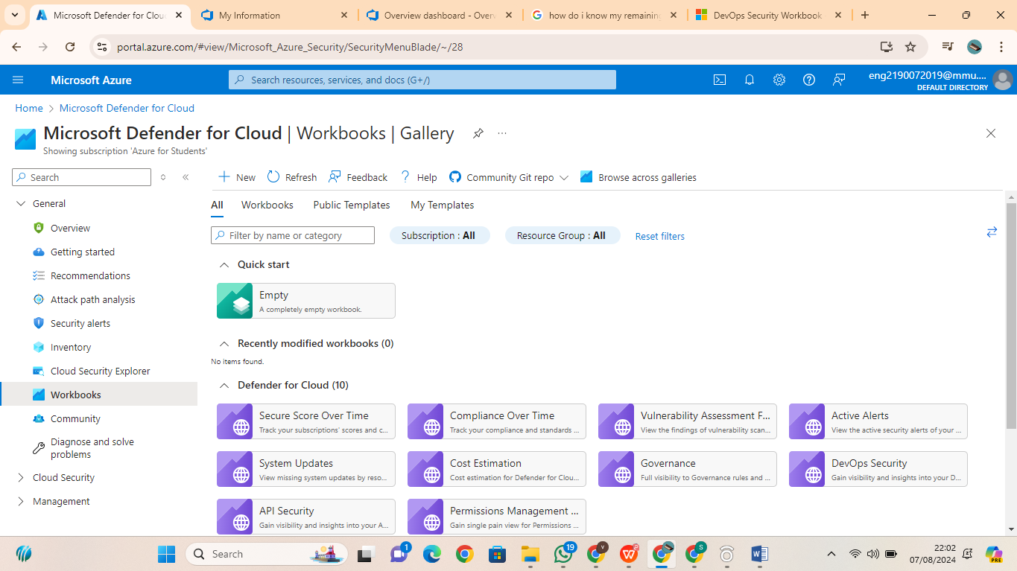

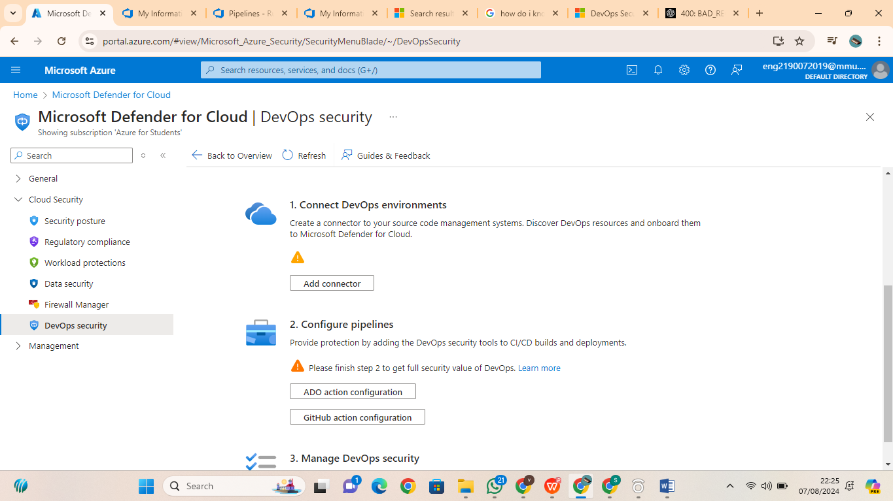

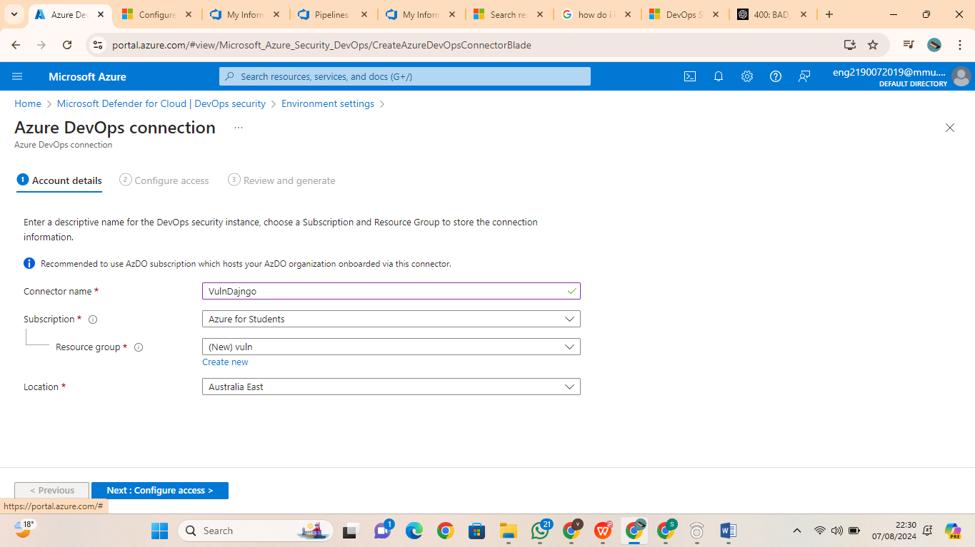

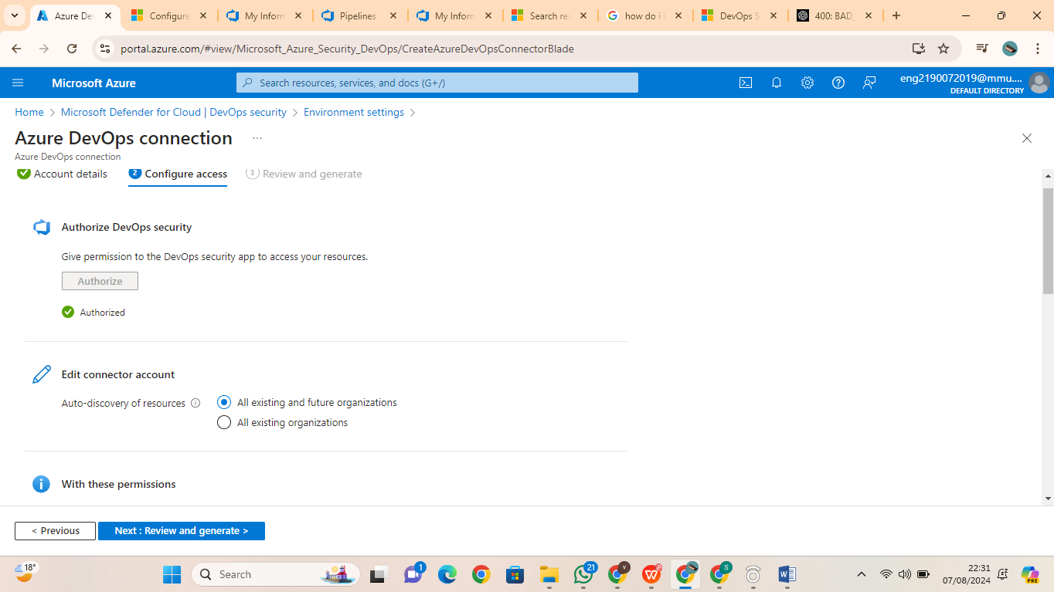

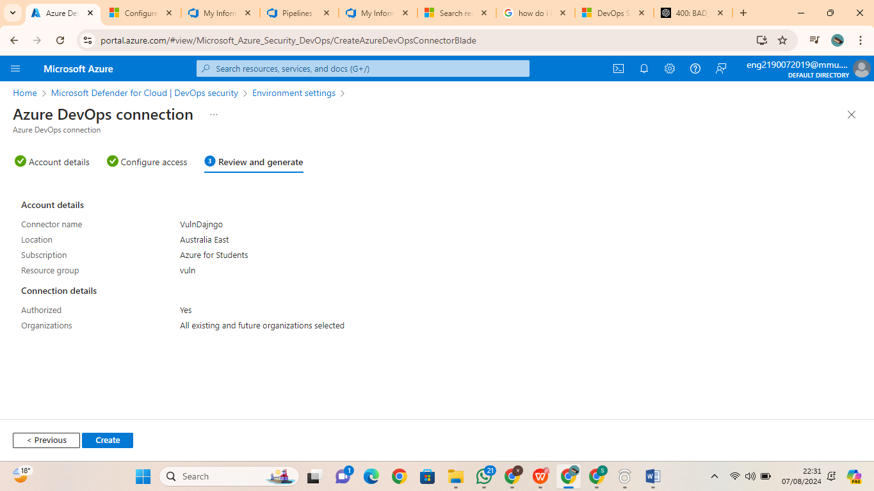

**Conclusion**

Completing this lab allowed me to deepen my understanding of integrating security practices into the DevOps pipeline. I learned how to effectively use static analysis tools to identify vulnerabilities in code, both locally and in CI/CD environments. Configuring Microsoft Security DevOps within Azure DevOps and GitHub provided me with practical skills to automate security checks and enhance the overall security posture of software projects. Additionally, working with the DevOps Security Workbook helped me appreciate the importance of continuous monitoring and reporting on security issues throughout the development lifecycle.